CAMBOND INNOVATION - BACKGROUND

Cambond has developed 100% plant based resin systems together with crosslinking agents designed to replace urea/formaldehyde resins in the woodpanel industry (Blocking-Crosslinking-Biomass Technology – BCB Technology). We already know that we can compete in the market on cost.

Recent development work at our facilities in Cambridge and China have shown that we can extend this technology to produce moulded and pressed products made from the resin and agricultural by- products.

The plant base resin (feedstocks include DDGS and algae) is a complex protein/lipid mixture which has been demonstrated to combine with the fibrous lignin containing phenol groups structure present in agricultural by-products (e.g. straws, peanut shells, palm oil waste, tops of pineapples). When extruded, moulded or pressed under heat and pressure the composite hardens and forms waterproof rigid structures. These containers do not leach chemicals and have been tested and certified according to EU and US standards.

We have produced prototype packaging for takeaway food and been able to demonstrate it is safe, cost effective, has performance comparable to plastics and can be re-cycled (like wood) or composted at home.

Cambond technology can be applied to meet the challenges of the restaurant industry and provide useful, effective, sustainable and low carbon products to meet its demands.

The adhesives used in wood panel industry include urea-formaldehyde, phenol-formaldehyde and isocyanate based adhesives (polyurethane adhesives). The chemistry for these adhesives are shown in Fig. 1, 2.

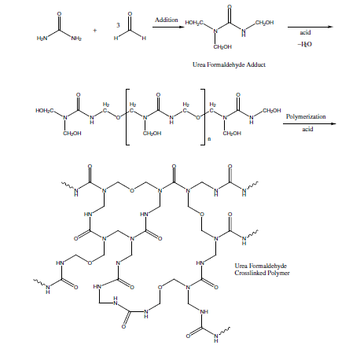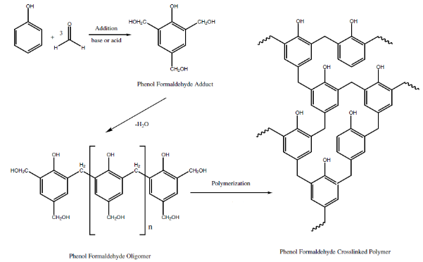

Fig.1 Urea-formaldehyde Synthesis / Phenol-formaldehyde Synthesis

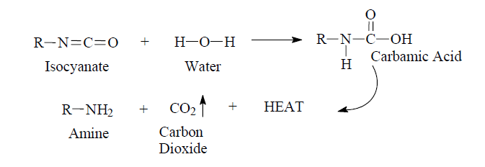

Fig.2 Isocyanate reacts with water to generate carbon dioxide.

The model blow reaction as shown in Fig.2 when isocyanate-based crosslinking agent is used for water containing materials involves the reaction of an isocyanate group with water to yield a thermally unstable carbamic acid which decomposes to give an amine functionality, carbon dioxide, and heat.

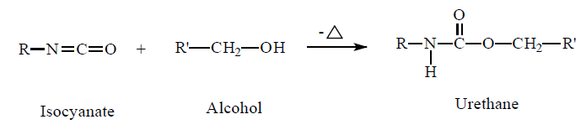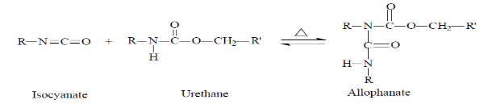

Fig.3 Crosslinking reaction scheme

The crosslinking reaction as shown in Fig 3 (sometimes called the gelation reaction) involves the reaction of isocyanate groups with alcohol groups to give urethane linkages to block the isocyanate groups and further react with another isocyante to form allophanate linkage to form a crosslinked network.

The BLOCKING-CROSSLINKING-BIOMASS (BCB technology) uses biomass containing phenol groups as shown in Fig.4, to react with isocyanate based crosslinking agent for blocking and it will de-block and react with biomass containing OH functional groups to form a stable biocomposite network under heat (Fig.5).

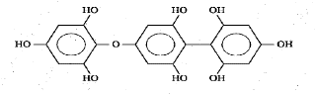Fig.4 Phenol functional groups





Fig. 5 Scheme of BCB technology

This chemistry has been patented for its use as a biological resin capable of being used to make biomaterials for use in the manufacture of many products.